**The effect of Bed Thickness on Hillslope Morphology and Sediment Size in Last Chance Canyon, New Mexico**

Sam Anderson1, Nicole Gasparini1, Joel Johnson2

1Earth and Environmental Science, Tulane University, New Orleans, 70118, USA

2Jackson School of Geosciences, University of Texas at Austin, Austin, 78712, USA

*Correspondence to*: Sam Anderson (sanderson@tulane.edu)

**Abstract.** In this study we explore the effect that hillslope bed thickness variations have on hillslope form, as well as channel grain size distributions and form, in Last Chance canyon, New Mexico, USA. The landscape is composed of horizontally to near horizontally bedded sandstone and carbonate rock. The hillslopes have relatively little regolith, yet most hillslopes have a convex diffusive shape despite the lack of continuous soil cover. We posit that differences in bedrock bed thickness influence hillslope shape in Last Chance canyon, where thinner bedrock generates a more diffusive geometry resembling the idealised convex hillslope shape endemic of soil mantled landscapes. We used drone photos to construct high resolution orthomosaics and digital elevation models (DEMs) of seven hillslope transects and stream channels at the base of each transect from two headwater catchments. Using these DEMs and orthomosaics, we measured bed thicknesses, slope, and curvature on the hillslopes and grain size distributions at the base of each hillslope. We find that hillslopes are steeper and less convex where there is more thickly bedded rock and become shallower and convex in thinly bedded rock. Furthermore, sediment input to channels is controlled by bed thickness on hillslopes and affects channel morphology. Thickly bedded rock units on proximal hillslopes contribute larger sized colluvial sediment to the channels, and these channel reaches have relatively high channel steepness index. We find that where hillslopes drain to relatively steep channel sections with coarse sediment, hillslope form transitions from convex to straight or concave, but where hillslopes drain to relatively shallow channel sections, hillslope form is predominantly convex. These observations suggest a tight coupling between hillslope bedrock properties, hillslope form, channel grain size distribution, and channel steepness.

# 1 Introduction (NOT MY DOG)

I RECOMMEND WE DEFINE AND DESCRIBE WHAT AN IDEAL HS IS.

Foto of end member parts of LS.

Hillslope curvature is a fundamental topographic characteristic that offers valuable insights into landscape dynamics. Typically, curvature exhibits a distinct pattern from the channel, located at the base of the hillslope, to the ridgeline, its highest point. Near the channel, curvature tends to be negative, reflecting the erosional processes associated with water flow, sediment transport, and fluvial incision. This concavity often results in the development of channels, gullies, and other erosional features. As one ascends towards the hillslope's midsection, curvature often transitions to relatively planar or gently convex profiles. Here, sediment deposition and weathering processes tend to dominate, creating a more stable environment conducive to soil formation and vegetation growth. Towards the ridgeline, curvature tends to be positive, indicating a pronounced erosional influence due to factors like surface runoff and mass wasting. This transition from concave near the channel to convex at the ridgeline represents the complex interplay of geological, climatic, and hydrological factors shaping hillslope morphology.

Could we use some of the drone imagery as motivation for the study? That's what got me so interested in the hillslopes to begin with.

# 2 Field Area

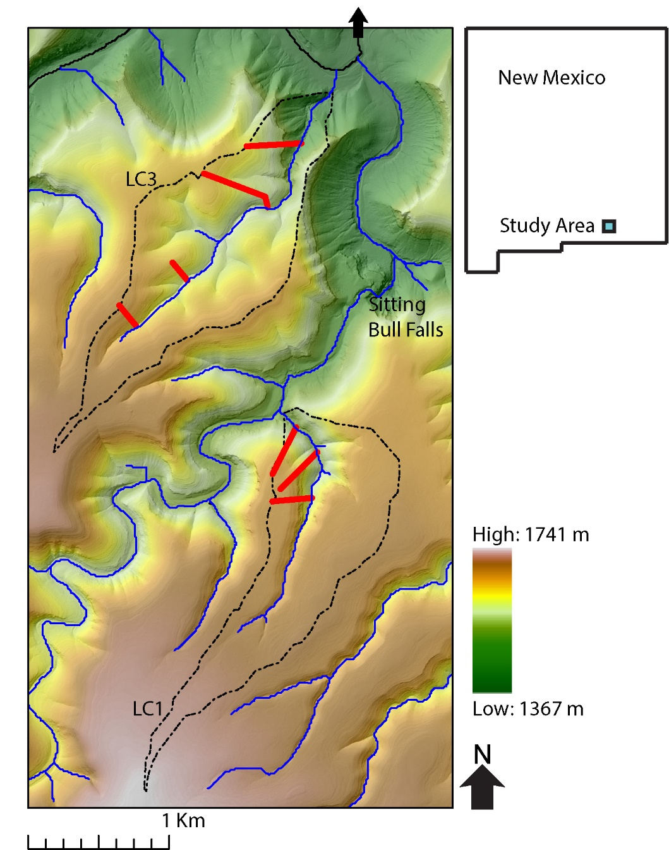

Figure 1: Topographic map with elevations superimposed on a hillshade of Last Chance canyon with ephemeral stream channels. Main stem of channel coloured black with arrow indicating the direction of stream flow. The two watersheds we took measurements in are outlined with dotted black line and labelled LC1 and LC2. The seven hillslope transects we surveyed are marked on the map with red bars.

We conducted fieldwork in Last Chance Canyon, located in the Guadalupe Mountains of southern New Mexico, USA. Because of their morphology and accessibility, we collected data along 2 different tributaries, called LC1 and LC3 (figure 1), and seven different hillslope transects that terminate at the base of each of the 2 stream channels (3 transects in the LC1 watershed and 4 transects in the LC3 watershed). These transects were chosen to capture variations in bed thickness and hillslope shape across the two watersheds. By examining the influence of bed thickness on hillslope form and sediment input to channels, we aim to better understand how changes in bed thickness correlate with boulder characteristics, stream channel shape, hillslope form and the morphology of Last Chance Canyon. Over the small spatial area and range of vertical elevations of the specific study channels, climate varies minimally. Mean annual precipitation is ≈40-50 cm/year, and mean annual temperature ≈14-16 ℃ (PRISM Climate Group). Last Chance Canyon has horizontally to near horizontally bedded bedrock and is currently tectonically inactive (Hill, 1987; Hill, 2006). During Permian time, a shallow lagoon existed behind a reef complex to the south and deposited what would become interbedded carbonate and siliciclastic bedrock of various thicknesses (Hill, 2000; Phelps et al., 2008; Kerans et al., 2017). The Guadalupe mountains were uplifted during basin and range extension beginning 27 million years ago, exposing the previously buried bedrock (Chapin and Cather, 1994; Ricketts et al.., 2014, Hoffman, 2014; Decker et al., 2018). Rock unit descriptions from published maps lack the relevant information needed to constrain bed thickness (NPS, 2007).

Last Chance canyon tributaries have upstream sections with relatively shallow channels and lower gradient hillslopes, and a knickzone downstream which has steep channels and hillslopes (map figure 2). LC1 has shallower hillslopes than LC3, and smaller bed thicknesses. Based on χ plots and field observations, we find that the stream channels transition from steep to shallow at approximately 1640 m for channel LC1 and at approximately 1550 m for channel LC3. The transition from steep to shallow is more subtle in LC1- χ changes less than in LC3. Both LC1 and LC3 have relatively little regolith. On average the depth to saprolite was 5.6 cm (standard deviation = 5.3 cm) and depth to bedrock was 20.1 cm (standard deviation = 15.5cm).

# 3 Methods

## 3.2 DEM Analysis

We used a 1 m digital elevation model (DEM) of Last Chance canyon to identify hillslopes of interest to survey, as well as channels at the base of the hillslopes. We calculated hillslope transects, slope, and curvature for 7 hillslopes and slope breaks along stream profiles at the base of the 7 hillslope transects (USGS, 2019). The normalized channel steepness index, *ksn*, is a measure of channel gradient normalized for drainage area (i.e., in principle allowing reach slope to be compared independent of drainage area):

$S=k_{sn}A^{-θ_{ref}}$ (#),

where $θ_{ref}$ is a reference concavity (Whipple and Tucker, 1999; Wobus et al., 2006). Based on a calibration to this landscape we use $θ_{ref}=0.5$, giving m-1 as the units for $k_{sn}$. Although *ksn* is an empirical metric of fluvial topography and not model dependent, if the stream power model is assumed to be valid then combining Equations (1) and (2) gives $E/K={k_{sn}}^{n}$, illustrating how this topographic metric potentially informs both erosion rates and erodibilities. *ksn* allows for the comparison of slope along a single channel or among multiple channels to isolate erosional and/or bedrock erodibility patterns (Kirby & Whipple, 2012). Because channels can adjust to more resistant lithologic units by steepening across them (Duval et al., 2004; Jansen et al., 2010) *ksn* maps to detect changes in slope that could be due to differences in bedrock erodibility and/or sediment size and cover. TopoToolBox and Matlab were used to generate longitudinal profiles, *ksn* maps of all surveyed channels (Schwanghart and Scherler, 2014).

## 3.3 Field Survey

In March and May of 2018, and in February of 2021, we surveyed 2 channels and 7 hillslope transects which we had preselected based on previous fieldwork, DEM analysis, mapped geology, and accessibility. Our investigation started in lower order channels and proximal hillslopes at elevations above 1400 m in channel LC3 and in elevations above 1500 in channel LC1 (map figure). USGS topographic contour maps of the field area use a 40 ft (≈12.2 m) contour interval. Following these maps for convenience and to ensure unbiased sampling, at every ≈12.2 m contour interval we measured the depth to both saprolite and bedrock along the 7 hillslope transects. At every contour interval along the 2 channels, we measured the size of the largest, assumedly most immobile, boulder in the channel. Previous work suggests that boulders and the coarsest sediment size fractions can significantly influence reach topography, erosion, and transport (e.g. REFS). For each boulder we measured the longest (a), intermediate (b) and shortest (c) axes (dog on rock figure). We multiply these dimensions together to approximate boulder volumes. We also constrain differences in boulder shape using the Corey Shape Factor (REF ):

$CSF=\frac{c}{\sqrt{ab}}$ (#)

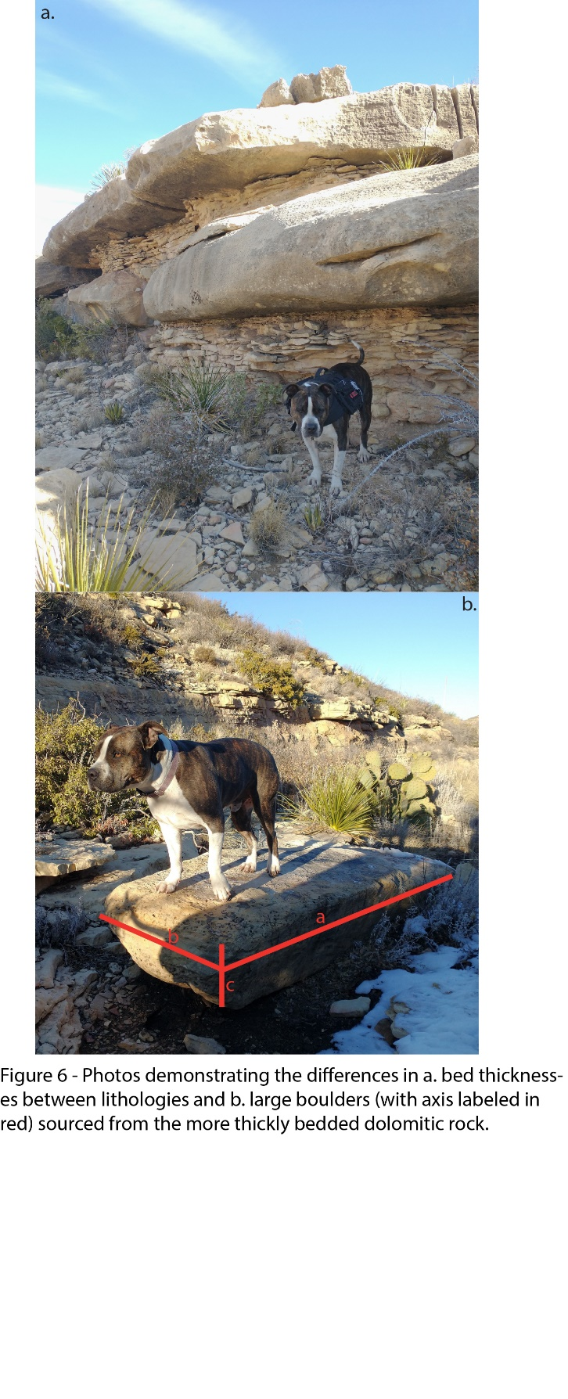

INCLUDE BOULDER MEASUREMENT EXPLANATION

## 3.4 Drone Based Photogrammetry

We used a drone, DJI Mavic 2 pro, to take photos of the 7 hillslope transects, along with photos of reaches from the 2 surveyed channels at the base of the 7 transects, at approximately 20 meters above the channels, and 20 meters above the highest elevation of the 7 hillslope transects. We used Agisoft photoscan to generate high resolution digital surface models (DSMs) with 0.027 to 0.28 m resolution (we refer to these as DSMs rather than DEMs because vegetation is not removed from the DSMs) and orthomosaics of the 7 hillslope transects and channel sections at the base of each transect. We used the orthomosaics to identify and measure exposed beds on the hillslopes. We used Agisoft Photoscan (Agisoft PhotoScan Professional, 2018) to generate high resolution orthomosaics and DSMs first by aligning the frames from the GoPro videos, then building a dense cloud, then creating a DEM and finally making an orthomosaic.

## 3.5 Photogrammetry to make Sediment Size Measurements

We measured the diameter of alluvium in channels at the base of the seven hillslope transects with the PebbleCounts image analysis package (Purinton and Bookhagen, 2019). PebbleCounts is a Python library for the detection and sizing of sediment grains from drone images. We used the k means with manual (KMS) method, which allows an operator to validate measured grains to mitigate error. To account for the large size of the orthomosaics, we first subset the images into manageable sizes. We then validated the results of the initial automatic counting with the k-means with manual (KMS) method, which allows an operator to validate measured grains and mitigate error. Finally, we compiled all the data for each channel section into a single file.

# 4 Results

## 4.1 Last Chance Canyon Morphology

Last Chance canyon has diffuse upslope sections and lower gradient hillslopes, and a downslope area which is relatively steep. which has steep channels and hillslopes (map figure 2). LC1 has generally shallower hillslopes than LC3,. Based on channel steepness maps and field observations, we find that hillslopes transition from steep to shallow at approximately 1640 m for channel LC1 and at approximately 1550 m for channel LC3. The transition from steep to shallow is more subtle in LC1- χ changes less than in LC3. Both LC1 and LC3 have relatively little regolith. On average the depth to saprolite was 5.6 cm (standard deviation = 5.3 cm) and depth to bedrock was 20.1 cm (standard deviation = 15.5cm).­­

**Figure 2 - a. Slope map of Last Chance canyon with values plotted across it. The contour lines correspond to elevations which are interpreted as approximate inflection points for hill and channel slope (1550m for LC 3 and 1640m for LC 1). b. Percentage of slope values from the hillslopes in LC3 and LC1. c. Cumulative frequency plots of bed thicknesses from the 4 surveyed hillslope transects on LC3 and the 3 surveyed hillslope transects on LC1.**

## 4.2 Bed Thickness and Hillslope Morphology

We observed patterns relating to the interplay between bed thickness and slope characteristics across our study area. Specifically, we found that variations in the average, maximum, and cumulative bed thickness within an 80-meter measurement window corresponded with variations in slope over the same spatial extent, as shown in the local slope vs. bed thickness figure. (local slope vs bed thickness figure). We chose to measure slope and bed thicknesses over a 80 m window because it diminished slope errors from boulders and plants over relatively larger distances. Furthermore, as the average bed thickness for a entire hillslope transects increases, the slope of the entire transect likewise increases (total slope figure). Beds are generally thinner in the upstream sections of the landscape, where hillslopes shallow.

It hurts in places where theres lots of bones.

­­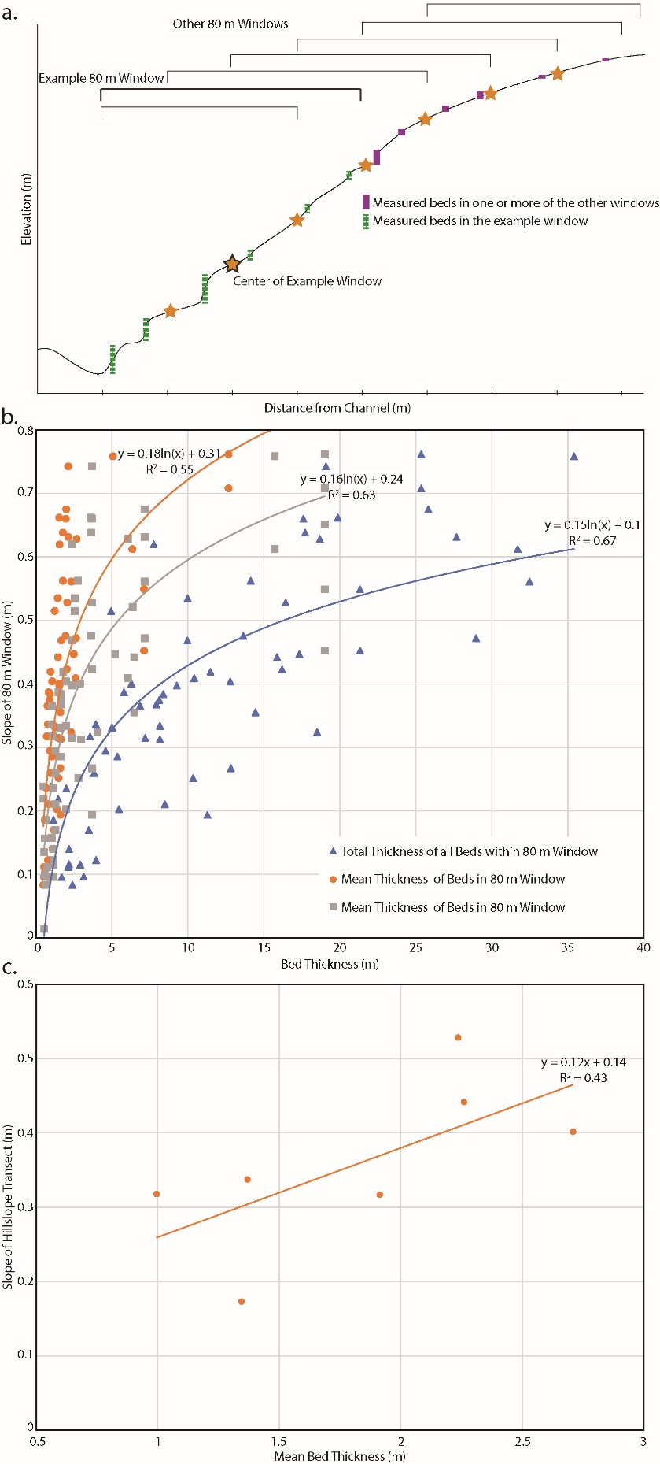

**Figure 3 – a. Schematic (not to scale) demonstrating how slope and bed thicknesses were calculated to generate the results presented in 5b. Mean bed thickness is the vertical height of measured beds divided by the number of measured beds within the 80 m window. Total bed thickness is the sum of the vertical height of all measured beds within the 80 m window. Max bed thickness is the vertical height of the largest measured bed in the window. Slope was calculated by subtracting the maximum from the minimum elevation of the 80 m window and then dividing the value by the distance. Figure 5b. shows the control that mean, max, and total bed thickness has on slope over an 80 m window. c. The mean bed thickness of each hillslope transect vs. the total slope of each hillslope transect.**

We plotted curvature values by distance from the channel in the seven hillslopes. On a hillslope transect in the shallow section of watershed LC3, curvature is positive at the ridgeline and decreases towards a negative value as the transect moves away from the ridgeline and towards the channel. The slope of the linear function describing the relationship between distance from the channel and curvature is negative (m = -0.012) and the r^2 value is 0.68, which is in agreement with what common perception of the manner curvature changes across a hillslope transect.

**I wonder if the "idealized" hillslope figure should go in the introduction?**

**I think you told me, but why can't we flip the x-axis on this figure to show it with the same orientation as Mudd?**

**Also, what about the form of the other hillslope transects? Is there a general pattern from up to downstream?**

## 4.3 Size of Alluvium and Boulders affects channel morphology

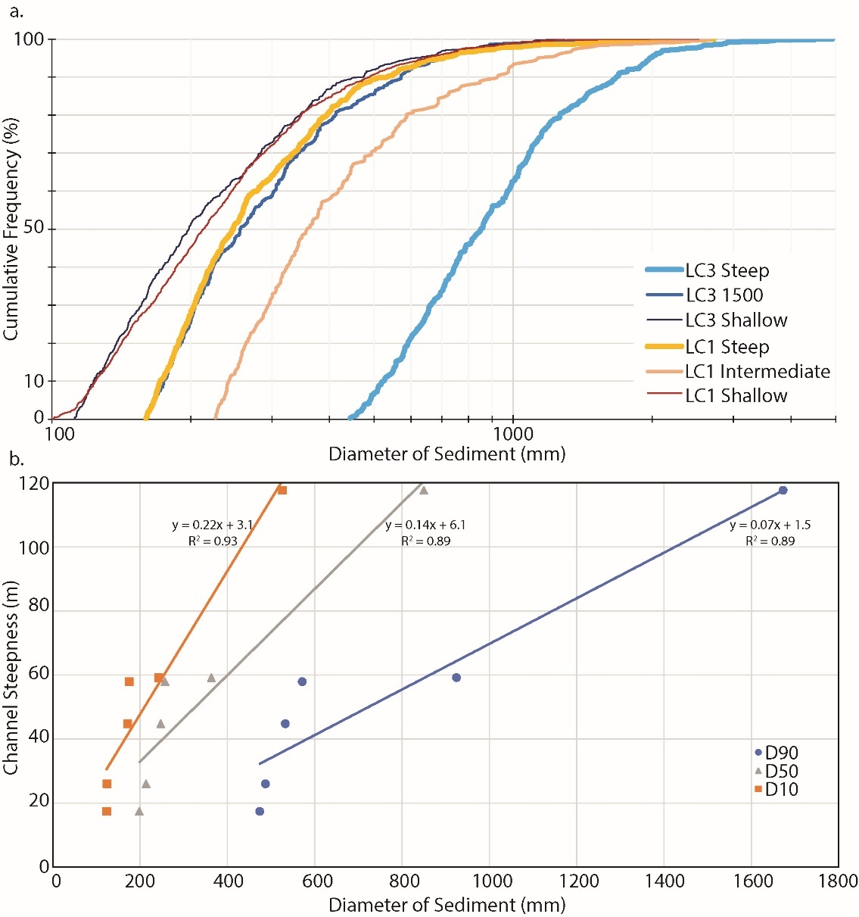

**Figure 4 – Two options. Either the figure above, or if fig2-option2 is chosen then figure4a will be removed**

Channel steepness is controlled by sediment diameter in the channel reaches at the base of the 7 hillslope transects we measured (figure4). An increase in sediment diameter corresponds to a concurrent increase in channel steepness, demonstrating a clear positive correlation between larger sediment sizes and the steepness of the channel profile. This observation emphasizes the significant influence of sediment dynamics on the fluvial system's morphology. Conversely, our findings also indicate that smaller sediment sizes are generally associated with shallower upstream hillslopes. This outcome underscores the role of particle size in shaping the topographic characteristics of hillslopes in proximity to the channel.

## 4.4 Bed thickness affects size and shape of Alluvium and Boulders

Variations in the maximum bed thickness were correlated with changes in the sediment diameter at the base of each hillslope transect (figures of bed thickness effect on grain size, and on channel steepness). The analyses revealed that as the maximum bed thickness increased, there were discernible effects on the D10, D50, and D90 of sediments present within the alluvium at the base of each hillslope transect, as well as the average sediment diameter. Conversely, the average bed thickness along a hillslope transect did not appear to significantly influence the diameter of sediment in the channel reaches below. These findings illuminate the intricate interplay between bedrock properties, sediment dynamics, and channel morphology, underscoring the importance of considering maximum bed thickness as a key factor in understanding the complex processes governing landscape evolution.

Isn't D84 coarser than D10?

Both maximum bed thickness and the average bed thickness along hillslope transects had a significant impact on the average dimensions of boulders, including their axis length (a, b, and c) and overall volume (figure of max and average bed thickness vs boulder volume and dimensions). The boulders were measured in the field and were the largest boulder in each reach. It's noteworthy that the relationship between average bed thickness and boulder dimensions, particularly axis length and volume, demonstrated a stronger correlation with boulder geometry than the maximum bed thickness. This finding underscores the importance of average bed thickness as a prominent factor in determining the dimensions of the large boulders within Last Chance canyon.

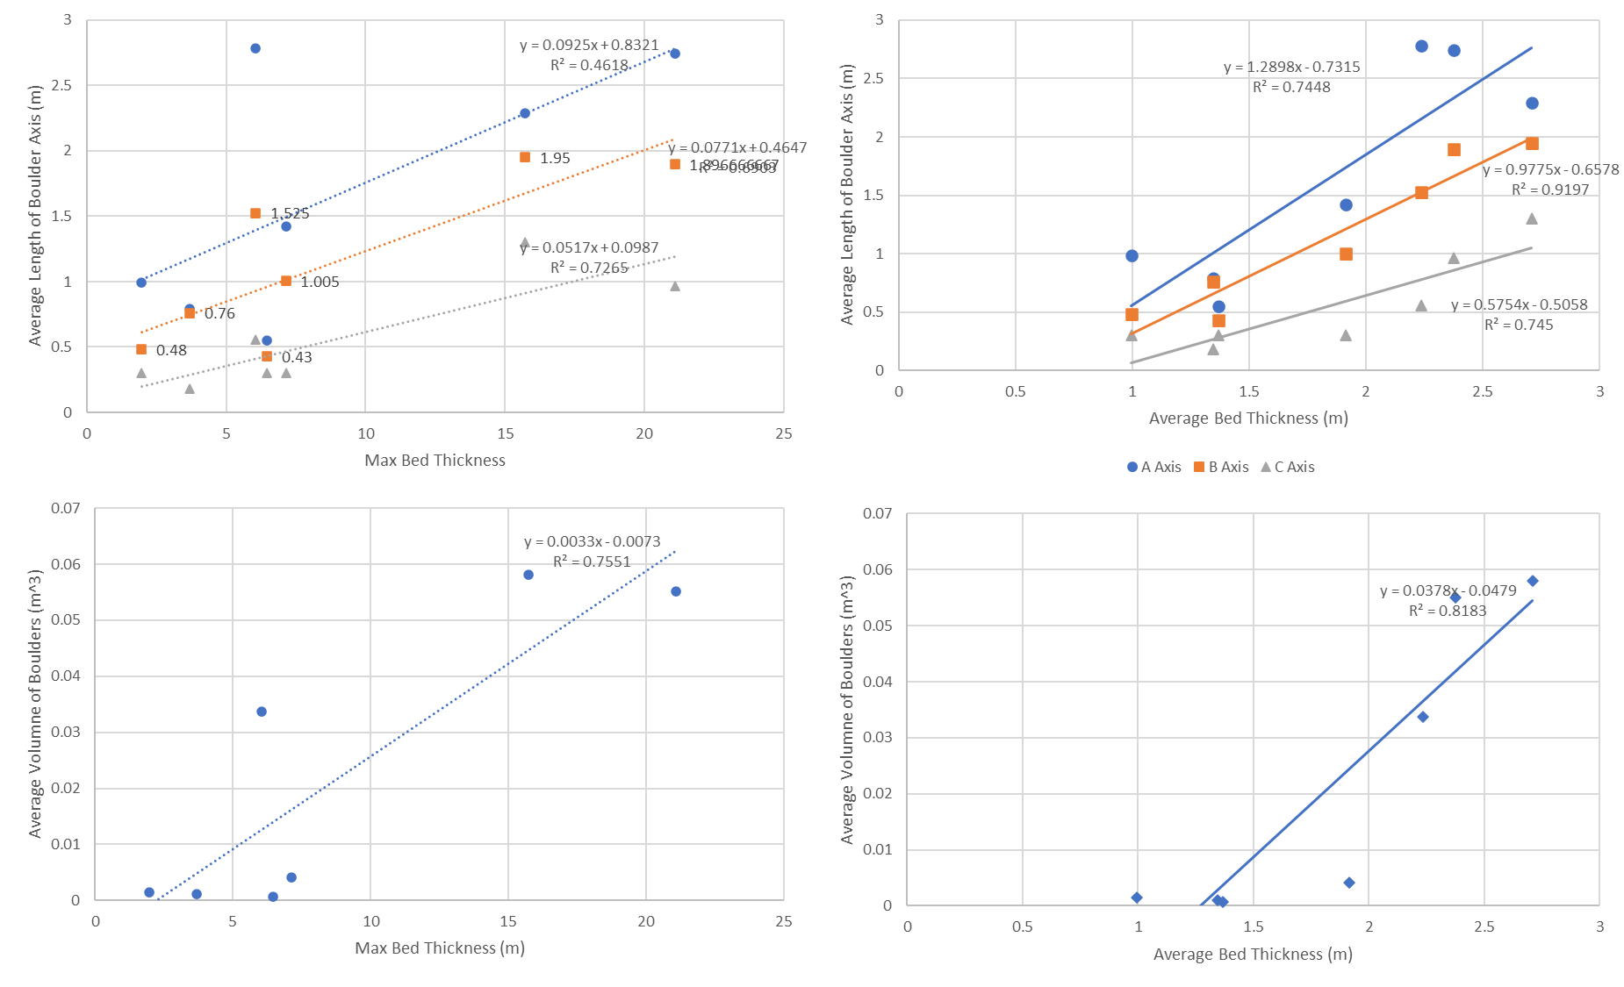Are those volumes correct? NOPE, TWO DECIMALS OFF They are very small. Are they from your field surveys? YES Is there something we can do for statistics besides just linear fits? TO SHOW CORRELATION? I know we don't have a lot of data. THERE IS MORE DATA, I COMBINED DATA FROM BOULDERS AT BASE OF HS SO ITS NOT JUST ONE BOULDER

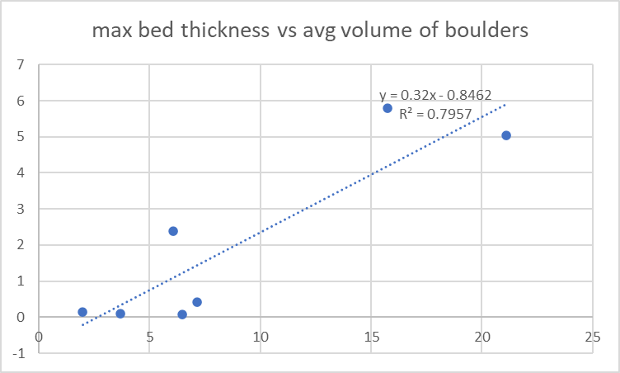

## 4.5 Bed thickness affects Channel Morph

In our results, we observed distinct relationships between bed thickness and channel steepness across hillslope transects. Specifically, we found that the maximum bed thickness along these transects exhibited a particularly strong influence on channel steepness, with a notable coefficient of determination (r^2 value) of 0.68. In contrast, the average bed thickness and the total bed thickness across the same transects also displayed correlations with channel steepness, albeit with comparatively lower r^2 values of 0.45 and 0.27, respectively. These findings underscore the significance of maximum bed thickness as a key factor in determining the steepness of the channels within the landscape, while also highlighting the varying degrees of influence associated with average and total bed thicknesses.

## 5 Discussion

In Last Chance canyon, hillslopes appear more diffuse in more thinly bedded rock at elevations higher than the thick beds at elevation 1540 m in LC3 and elevation 1640 m in LC1. The term "idealized hillslope" may provide a more accurate descriptor than "diffusive." Furthermore, hillslopes with less variance in bed thickness appear more “idealized”. Diffusive hillslopes are convex near the ridgeline and become more concave as the hillslope approach the channel. We plotted the slope values and the r squared values for the seven transects against max bed thickness and found that where the max bed thickness is lower, the slope of the distance vs curvature function is more negative and has a higher r-squared value, both indicating a more diffusive shape. We believe the spread in the data is due to position of the hillslope in the landscape. We did not take drainage area into account when plotting hillslope curvature (slope of function and r^2 of function figure). Also, hillslope transects that have more variation in bed thickness appear less diffuse suggesting that a hillslope made of a variety of different bed thicknesses can cause a hillslope to appear less diffuse.

Bed thickness varies across the landscape and etches their signal on it’s morphology. In Last Chance canyon, differences in measured bed thickness affect morphology in multiple ways. Here, we introduce three key interpretations from our study. (1) Relatively thick beds cause hillslopes to steepen and straiten downslope of them and thinly bedded areas upslope of thick beds appears diffuse. (2) Bed thicknesses along hillslopes affects the size and dimensions of large boulders and the diameter of alluvium in channel reaches at the base of hillslope transects. Bed thickness affects channel steepness by contributing larger or smaller sediment and boulders to channel at its base. 3) We interpret that thick beds slow and inhibit the signal from the erosional wave moving up channel as a result of baselevel fall. Thick beds here are inflection points between low sloping and diffuse relict topography above them and steep adjusting topography below them.

Putting these three interpretations together, we hypothesize that despite the change from low steepness upstream to high steepness downstream in our study channels, this is a relatively stable morphology in the current situation. We hypothesize that the channel sections with high steepness are not eroding due to the more massive carbonate units and the large, immobile boulders armouring the channel, both of which lead to low channel erodibility. If the channel sections with high steepness are not actively eroding, this creates a pinned base level for the low steepness channel sections upstream. This pinned base level leads us to hypothesize that the high erodibility, low steepness upstream channels are also not eroding, creating an overall stable morphology.

## 5.1 Bed Thickness and Hillslope Morphology

Figure with bed thickness mapped across hillslope transects

## 5.2 Bed Thickness, Coarse Sediment Production, and Channel Morphology

Describe all the figures involving channels from the results

More thickly bedded and higher relief hillslopes contribute larger-sized and more geomorphically relevant boulders from the hillslopes to the channel (Neely et al., 2020) (Figure 7). The steep channel sections of Last Chance Canyon are incised into relatively narrow canyons, in comparison with the upstream, low steepness portions of the landscape. Hillslope derived sediment from the thickly bedded units in the canyon wall armors the channel bed in the steep reaches. We think these boulder deposits allow the relatively weak sandstone channel reaches to steepen through boulder deposition, as has been shown elsewhere (Shobe et al, 2016; Thaler and Covington, 2016; Chilton and Spotila, 2020). We assume that there are carbonate reaches that are also amorered in sediment. However, where bedrock is exposed in the steep channels, it is predominantly carbonate rocks, which are harder and presumably less erodible than the sandstone reaches (see subsection above). Within these steep channel sections which are inundated with sediment, we interpret that channel slope is somewhat independent of bedrock properties and instead depends on the amount, size, and competency of sediment armor sourced from proximal hillslopes. In other words, we think that the larger sediment armoring the steep reaches effectively decreases the erodibility of these reaches.

Bed thickness and fracture patterns control the initial size of sediment supplied by hillslopes to channels (Sklar et al., 2017; Verdian et al., 2020; Shobe et al., 2021). In Last Chance canyon, the maximum length of one axis of a boulder entering a channel from proximal hillslopes is controlled by the distance between bedding planes and fractures. In carbonate bedrock the distance between bedding planes tends to be longer than in sandstone bedrock. Where hillslope relief increases, bedrock units are thicker, and the length of the a, b, and c axes increases for the carbonate boulders (Figure 7). (We do not have measurements of discontinuity intensity from the hillslopes. Our observations were that steep hillslopes were primarily composed of massive carbonate.) In sandstone boulders, the c axis correlates with hillslope relief, the b axis length also correlates with relief, but to a lesser extent, and the a axis length does not demonstrate any relationship with relief. Because sandstone bedrock is more thinly bedded, the c axis (shortest) will tend to reflect the distance between bedding planes from the source rock.

The carbonate boulders are more equidimensional and have a higher average shape factor of 0.36 in comparison with the sandstone boulders which have an average shape factor of 0.29. Although small, this difference in shape factor may reflect how the distance between bedding planes affects sediment shape. Because a sediment grain tends to break across its shortest axis, the more elongate sandstone boulders are less competent than carbonate boulders (Allan, 1997). Abrasion also reduces boulder size and may decrease the size of elongate boulders more rapidly (e.g., Miller et al., 2014). Also, this could be why there were less sandstone than carbonate boulders. Of the 58 boulders we measured, 70% in the steep channel section and 64% in the shallow were carbonate. Because carbonate bedrock is thickly bedded, boulders sourced from this bedrock tend to be larger. Further, because the carbonate boulders are more equidimensional, they likely stay larger for longer than sandstone boulders.

## 5.3 Do Thick Beds Protect Relict Topography Upslope of Them?

3d schematic, make figure that shows the slope of the inflection point across the landscape and describe it as space for time

We interpret that erosion is inhibited due on the hillslope due to the presence of thick bedrock and in the steep reaches of our study channels due to large boulders and bigger alluvium that we interpret to be immobile.

The downstream portions of our study channels are both steeper and have higher steepness indices than the upstream channel lengths and high steepness indices are thought to correlate with high erosion rates and/or less erodible rocks (Hilley and Arrowsmith, 2008). Although we do not have measurements of erosion rate in Last Chance canyon, we make the link between channel steepness and erodibility by assuming all channel reaches have a similar, low, erosion rate. In other parts of the Guadalupe Mountains, west of Last Chance canyon, erosion rates do not vary systematically with rock type, nor with slope (Tranel, 2020). We suggest that spatial variations in erodibility, rather than spatial variations in erosion rates, controls channel steepness in our study channels.

We further hypothesize that the upstream channel sections also have low erosion rates but for a different reason. These channel reaches have lower slope and lower channel steepness indices (Figures 5, 9). The upstream channel reaches are less armoured and have more sandstone exposed in the channel than their downstream reaches. These observations suggest that these upstream reaches are likely more erodible. Past erosion has reduced channel slopes leading to lower channel steepness.

The distinct upstream, low steepness channel and downstream high steepness channel is not consistent in all of our study channels. χ plots for channels LC 3, 4, and 5, demonstrate two well defined channel sections, where in the higher elevation, lower relief, and lower slope section above 1550 m there is more exposed bedrock, more exposed sandstone, less alluvium, and smaller boulders armoring the channel (Figure 9). In contrast, LC 1 and 2 lack the obvious transition from downstream steep section to upstream shallow section observed in LC 3, 4, and 5. We interpret that the less notable change in upstream steepness in LC 1 and 2 is due to the armoring of sandstone rock units and relative abundance (in comparison with LC 3, 4, and 5) alluvium above 1550 m in elevation. Lithology measurements from proximal hillslopes in LC 1 and 2 indicate that just above elevation 1550 m there are sandstone units in the channel, as there are in LC 3, 4, and 5, but they are buried by alluvium in LC 1 and 2 (Figure 9, Table 1). We note that the transition to a lower steepness occurs at a higher elevation in LC 1 and 2, at about 1640 m (Figure 5) and it may be less distinct in comparison with LC 3, 4, and 5. We do not know why there is more extensive armouring in LC 1 and 2 in comparison with LC 3, 4, and 5. One possibility for this armour is the outcropping of the Queen formation on the hillslopes above LC 1 and 2 but not above LC 3, 4, and 5 (Figure 2). Regardless of the reason, the fact that LC 1 and 2 remain steep even when the channel bed is sandstone supports our idea that sediment cover can hide the properties of the local bedrock and impact channel morphology

Through landscape evolution modelling using the stream power model (Equation 1), Forte et al. (2016) showed that where more erodible rocks upstream are underlain by less erodible rocks downstream, the upstream reaches can have an effectively pinned base level, such that channel steepnesses evolve to reflect the contrast in rock properties. Our overall interpretation of the Last Chance Canyon landscape is consistent with bedrock properties exerting this type of control. We also note that Perne et al. (2017) demonstrated that if topography is adjusted to bedrock erodibility in horizontally layered rocks, erosion rates should only be consistent if measured parallel to the layering. We interpret the Last Chance Canyon landform to approximate a steady state geometry, but relative to the horizontal bedding over time (Perne and Covington, 2017). Our bedrock properties data also illustrate challenges in directly linking measurable rock properties to bedrock channel reach erodibility. However, our data also suggest that coarse sediment—rarely mobile boulders which reflect nearby bedrock eroding from hillslopes, but not the local channel bed itself—are a key mechanism by which lithologic contrasts are expressed in this landscape. Future work could explore how boulder transport may move and disperse zones of lithologic control downstream from boulder source areas. Regardless, we interpret that the bimodal topography in Last Chance Canyon– low to high steepness channels and less steep to steeper hillslopes - has evolved to reflect the rock properties of the two dominant lithologies, both locally and non-locally.

Our observations further underscore the significance of bed thickness in shaping the overall landscape morphology. The transition from upstream to downstream sections of the landscape, where hillslopes tend to become shallower, aligns with the thinner bedrock beds typically found in upstream regions, as well as smaller sediment and boulders. This systematic variation in bed thickness across the landscape accentuates the concept of hillslope convexity and its dynamic relationship with bedrock properties.

## 6 Conclusions

We present several observations about the effects of bed thickness on landscape form in hillslopes and proximal tributaries of Last Chance canyon. We suggest that bed thickness influences hillslope processes. Areas on a hillslope with relatively thick beds cause hillslopes to straighten and steepen below them. Conversely, hillslopes appear diffuse above these areas of exposed and thick beds.

The size of alluvium and boulders in channels sourced from beds on hillslopes above channel reaches also landscape morphology. Thicker beds on the hillslopes contributes larger alluvium and boulders to the channel. This coarse sediment inhibits erosion and causes channels to steepen. Last Chance canyon, channel sections that contain larger alluvium and boulders are steeper.

Finally, we interpret that the large beds diminish the erosional signal at higher elevations from base level fall. The more diffuse hillslopes at the top of Last Chance canyon have a base level that is pinned by the thick beds downslope of them.

**NICOLE QUESTIONS:**

**• How much is mean controlled by max? Is median different from max? It seems like max should be what is most important.**

The max values strongly shift the mean away from the median. Max seems important, but does this mean that I should avoid mean and total measurements?

**• I have a very hard time understanding how a convex hillslope can form where beds are thick and exposed. Do we see that? Is there any way to show that it doesn’t happen?**

**I guess it depends on what you mean by thick? I wonder if there is like a threshold max bed thickness above which curvature is 0 or +, but I guess it would also have to depend on where it is on the HS. That’s where I am kinda struggling- as is with many things in geology, there are multiple things happening at once so it’s hard to control for, in this case, curvature values changing with distance from channel AND bed thickness. See the curve plot here, doesn’t really say much to me.**

**• It would be nice to expand your hillslope dataset. Even if you don’t have bed measurements, you can make more hillslope profiles. We know beds are near horizontal, so you can make some inference about bedding in other hillslopes. My challenge right now is that there aren’t hillslope profiles in the paper and it’s really hard to take away whether these hillslopes are convex or concave. Can you make an arc map?**

10-24-23

I want to relate this back to the landscape. I have a buncha plots which speak to a buncha different things going on, but not a lot of focus. I want to say that HS are “ideal” and appear diffusive above a certain point. Maybe that point is a big bed, or series of beds. What happens at that “inflection point”? I can show that graphically by plotting the transects with beds mapped across them. Maybe it’ll give me focus. After I’ll try and plot curvature and slope down each transect in a cell by cell measurement. Maybe after I can plot some of the metrics above and below that point to show how morphology changes?

I also want to express the effect that drainage area has. Maybe I could frame this as “distance from the inflection pt on the landscape”, or like distance above and below? Or something like that. I want to make the 3d schematic that Nicole drew out, which was oriented up channel at a watershed (schematic, lc 1 or lc3 or both) and draw a line at the infection point. I want to show the difference above and below this point. With this I can justify why the upchannel plots look more diffusive. Here I can say that whether this landscape is bedrocky doesn’t much affect whether it appears diffusive, it’s the max size (or amount of) beds

After this I can say that these large beds produce large sediment which armors the channel below (not above) and so everything below this point is steepend. Maybe steeper HS better transport large sediment downslope as well.

1. Plot out profiles with mapped beds, do curvature and slope measurements (mean, max, etc) above and below a inflection elevation, on windows, total. Find where curve is +, 0, and – and find inflection pts. Find elevation where above which is relict topo (diffusive) and below (adjusting) is it worth plotting the 1m and the drone dsm on the same fig?
   * 1. Make insets of curvature plots (curve on y axis, distance from channel on the x)
     2. Curvature is too messy, the 10m DEM didn’t work. Maybe I can use std dev, or when figure gets “messy”. Another workaround is plotting beds on a elevation profile and using that.
   1. Try and find a trend to see if these elevations change with drainage area
   2. Make more profiles and/or clip the DEM and get curvature values above and below between these elevations
   3. For example, elevation on y axis, curvature on x, lines separating elevation inflection pts- plot all curve values and see if they fit into bins. Then, do a multivariate t test to see if the populations are different
2. Make 3d map of the two watersheds with inflections drawn on
3. Re evaluate and potentially remake the weird curvature figure but make it above and below inflection points
   1. For example, remake the figure but adjust the r^2 and m values only using curvature values above the elevation where topo is relict (diffuse)

Also, I want some pics of the holes I dug to show how little regolith is here.

1. Make profiles all with same axis values
2. Map beds across each
3. Make figure with curvature on y and distance from channel on x (all axis will be the same)
   1. This will be an inset maybe
4. Use the combo of this data to identify inflection points to determine the following
   1. Elevation above which topo is relict and diffusive
   2. Elevations above which curvature is -, 0 and + respectively
5. Clip dem above/blow inflection of relic and adjusting elevation,
6. Bin curvature by elevations below + inflection, at 0, and above - curve values
7. Make plots

Some thoughts. A erosional wave will move up a horizontally bedded landscape and get “hung up” on large beds (max or total bed thickness as it moves). The intensity of the wave will diminish as it moves and gets ‘stuck’ on beds farther downstream. Also, its intensity will get modulated by the increase in alluvium contributed by the HS to the channels as it moves upstream. I think the presence of the wave will cause a horizontal landscape to respond in way where inflection point between the reliect and adjusting topography is not horizontal across the landscape, but is oriented in a positive direction with decreases in drainage area and/or increases in distance upstream. Because of this, natural curvature change across a hillslope is affected differently as one moves upstream

1. Is there a way to show how much the thickness of a bed can dampen the signal from the wave, even if its relative?
   1. It will do it in 2 ways, one via the bed itself, and the other by the size of the sediment the bed contributes to the channel.
      1. Maybe the bed thickness will change the angle, making it more steep. The difference between LC1 and LC3 expresses this (the inflection of LC1 is approx. 1640, same as paper 1)
   2. Also, this will vary with time, when the wave hits the bed it will be more hung up the close the bed is to the channel, as the distance the sediment has to travel from the hillslope to the channel will be longer and the sediment will be thicker

Some thoughts after looking at the profiles…. A erosional wave will move up a horizontally bedded landscape and get “hung up” on large beds (maybe max or total bed thickness is a good proxy measurement for this) as it moves upstream. The intensity of the wave will diminish as it moves and gets ‘stuck’ on beds farther downstream. This will vary spatially and temporally, when the wave hits a big ol bed it will be more hung up the closer the bed is to the channel, as the distance the sediment has to travel from the hillslope to the channel will be longer and the sediment will be thicker.(not exactly sure what this means, but most of this text is spot on to me. I know it’s a draft but I like the direction) Also, its intensity of the erosional wave will get modulated by more alluvium contributed by the HS to the channels as it moves upstream. I think the presence of the wave will cause a horizontal landscape to respond in way where inflection point between the reliect and adjusting topography is not horizontal across the landscape, but is oriented in a positive direction with decreases in drainage area and increases in distance upstream. Because of this, natural curvature change across a hillslope is affected differently as one moves upstream, where hillslopes will begin to look more diffuse at different elevations across the landscape. Take it in this direction! I love this.

Is there a way to show how much the thickness of a bed can dampen the signal from the wave, even if its relative? I think It will do it in 2 ways, one via the bed competency itself, and the other by the size of the sediment the bed contributes to the channel. Maybe something about the presence of beds ( maybe max or total bed thickness this seems the most likely to work to me) will change the elevation of the inflection point between relict and adjusting topo is upstream of the bed, where a thicker bed will cause the erosional wave to get “more hung up” yes and then make the next inflection point upstream to be at a higher elevation. (not sure I’m following. Do you mean that if there is a big bed in the hillslope, the erosion wave will get stuck on it, so the inflection point on the hillslope will be closer to that big bed? ) Maybe it could be the position of the largest bed is along the HS transect. Seemingly the difference between the inflection points in LC1 and LC3 expresses this (the inflection of LC1 is approx. 1640, same as paper 1) with very little difference between the elevation of downstream (1640m) and upstream inflection (1660-1670m). where in LC3, the difference is large (1560 downstream to 1660 upstream). A cursory look at the bed thickesses shows that LC3.3 (the farthest downstream transect) has some big ol beds in the adjusting section. 1.1, 1.2, and 1.3 do as well (and 1.4 has some bigish ones spaced across it. Maybe this is why lc1 doesn’t have much of a change in elevation in inflection pt? IDK, Im rambling now. (I’m a bit lost in this, but I like where you are going. I think I need a schematic/plots to help me through this. You are unraveling the landscape.)

From mudd- detection of transieince

many cases, one might wish to look for evidence of landscape transience across multiple hillslopes. One strategy is to look for a transition between low relief and high relief surfaces, which may be interpreted as separating slowly eroding from rapidly eroding portions of the landscape (e.g. Schoenbohm et al., 2004; Gallen et al., 2011; Anderson et al., 2012; Prince and Spotila, 2013). If changes in hillslope erosion rates are driven by the propagation of knickpoints up the channel network, one might expect to find a pattern of hillslope disturbance in which the proportion of the hillslope affected by the greater erosion rate increases downstream of the channel knickpoint (e.g. Mudd and Furbish, 2007; Hurst et al., 2012

. In addition, in most rapidly eroding landscapes, hillslopes tend to approach a critical slope angle (e.g. Roering et al., 2001; Binnie et al., 2007; DiBiase et al., 2010) and thus at high erosion rates, hillslope gradients become insensitive to erosion rate

Do we see this? Maybe in LC3

In landscapes with changing erosion rates at base level, signals propagate upstream and upslope (e.g. Whipple and Tucker, 1999). These signals then move up the channel network at a rate controlled by drainage area and the fluvial erodibility coefficient (e.g. Whipple and Tucker, 1999; Royden and Perron, 2013) and then spread to hillslopes (e.g. Mudd and Furbish, 2007; Reinhardt et al., 2007; Prince and Spotila, 2013). Because these signals propagate upslope, they can be thought of as ‘bottom-up’ drivers of landscape transience (e.g. Bishop, 2007). However, if erodibility coefficients or sediment transport coefficients change, or erodibility! we might reasonably expect the entire landscape to act in concert.

In soil mantled landscapes, the relationship between ridgetop curvature and hillslope relief can be a powerful indicator of landscape transience. Roering et al. (2007) demonstrated that normalized forms of relief (R*) and hilltop curvature (E*) should lie on a single curve if a hillslope is in steady state. Deviations from this curve, therefore, should indicate landscape transience, as demonstrated by Hurst et al. (2013a). In this contribution I show that one should be able to resolve a doubling of erosion rate using this technique, and that the signal should persist for hundreds to thousands of years in most landscapes

Maybe use relief vs curvature BUT AT LEAST SLOPE BREAK IS USED

(e.g. Schoenbohm et al., 2004; Gallen et al., 2011; Anderson et al., 2012; Prince and Spotila, 2013

# Old References

Bell, F. G. (2005). ENGINEERING GEOLOGY| Problematic Rocks.

Bursztyn, N., Pederson, J. L., Tressler, C., Mackley, R. D., & Mitchell, K. J. (2015). Rock strength along a fluvial transect of the Colorado Plateau – quantifying a fundamental control on geomorphology. Earth and Planetary Science Letters, 429, 90–100. doi:10.1016/j.epsl.2015.07.042

Chapin, C. E., Cather, S. M., & Keller, G. R. (1994). Tectonic setting of the axial basins of the northern and central Rio Grande rift. Special Papers-Geological Society of America, 5–5.

Chilton, K. D., & Spotila, J. A. (2020). Preservation of Valley and Ridge topography via delivery of resistant, ridge-sourced boulders to hillslopes and channels, Southern Appalachian Mountains, U.S.A. Geomorphology, 365, 107263. doi:10.1016/j.geomorph.2020.107263

Darling, A., & Whipple, K. (08 2015). Geomorphic constraints on the age of the western Grand Canyon. Geosphere, 11(4), 958–976. doi:10.1130/GES01131.1

Decker, D. D., Polyak, V. J., Asmerom, Y., & Lachniet, M. S. (2018). U--Pb dating of cave spar: a new shallow crust landscape evolution tool. Tectonics, 37(1), 208–223.

DiBiase, R. A., Rossi, M. W., & Neely, A. B. (2018). Fracture density and grain size controls on the relief structure of bedrock landscapes. Geology, 46(5), 399–402. doi:10.1130/G40006.1

DiBiase, R. A., Whipple, K. X., Heimsath, A. M., & Ouimet, W. B. (2010). Landscape form and millennial erosion rates in the San Gabriel Mountains, CA. Earth and Planetary Science Letters, 289(1), 134–144. doi:10.1016/j.epsl.2009.10.03

Duvall, A., Kirby, E., & Burbank, D. (2004). Tectonic and lithologic controls on bedrock channel profiles and processes in coastal California. Journal of Geophysical Research: Earth Surface, 109(F3). doi:10.1029/2003JF000086

Forte, A. M., Yanites, B. J., & Whipple, K. X. (2016). Complexities of landscape evolution during incision through layered stratigraphy with contrasts in rock strength. Earth Surface Processes and Landforms, 41(12), 1736–1757. doi:10.1002/esp.3947 Finnegan, N. J., Klier, R. A., Johnstone, S., Pfeiffer, A. M., & Johnson, K. (2017). Field evidence for the control of grain size and sediment supply on steady-state bedrock river channel slopes in a tectonically active setting. Earth Surface Processes and Landforms, 42(14), 2338–2349.

Harel, M.-A., Mudd, S. M., & Attal, M. (2016). Global analysis of the stream power law parameters based on worldwide 10Be denudation rates. Geomorphology, 268, 184–196. doi:10.1016/j.geomorph.2016.05.035

Healy, D., Rizzo, R. E., Cornwell, D. G., Farrell, N. J. C., Watkins, H., Timms, N. E., … Smith, M. (2017). FracPaQ: A MATLABTM toolbox for the quantification of fracture patterns. Journal of Structural Geology, 95, 1–16.

Hill, C. A. (1987). Geology of Carlsbad cavern and other caves in the Guadalupe Mountains, New Mexico and Texas. Bull. 117, New Mexico Bureau of Mines and Minerals Resources.

Hill, C. A., & Others. (2000). Overview of the geologic history of cave development in the Guadalupe Mountains, New Mexico. Journal of Cave and Karst Studies, 62(2), 60–71.

Hill, C. A. (2006). Geology of the Guadalupe Mountains: An overview of recent ideas. Caves and karst of southeastern New Mexico: Guidebook, 57th Field Conference, New Mexico Geological Society, Guidebook, 57th Field Conference, 145–150.

Hilley, G. E., & Arrowsmith, J. R. (2008). Geomorphic response to uplift along the Dragon’s Back pressure ridge, Carrizo Plain, California. Geology, 36(5), 367–370.

Hoffman, L. L. (2014). Spatial variability of erosion patterns along the eastern margin of the Rio Grande Rift. Illinois State University.

Jansen, J. D., Codilean, A. T., Bishop, P., & Hoey, T. B. (2010). Scale dependence of lithological control on topography: Bedrock channel geometry and catchment morphometry in western Scotland. The Journal of geology, 118(3), 223–246.

Johnson, J. P. L., Whipple, K. X., Sklar, L. S., & Hanks, T. C. (2009). Transport slopes, sediment cover, and bedrock channel incision in the Henry Mountains, Utah. Journal of Geophysical Research: Earth Surface, 114(F2). doi:10.1029/2007JF000862

Katz, O., Reches, Z., & Roegiers, J.-C. (2000). Evaluation of mechanical rock properties using a Schmidt Hammer. International Journal of rock mechanics and mining sciences, 37(4), 723–728.

Keen-Zebert, A., Hudson, M. R., Shepherd, S. L., & Thaler, E. A. (2017). The effect of lithology on valley width, terrace distribution, and bedload provenance in a tectonically stable catchment with flat-lying stratigraphy. Earth Surface Processes and Landforms, 42(10), 1573–1587.

Kerans, C., Zahm, C., Garcia-Fresca, B., & Harris, P. M. (2017). Guadalupe Mountains, West Texas and New Mexico: Key excursions. AAPG Bulletin, 101(4), 465–474.

Kirby, E., & Whipple, K. X. (2012). Expression of active tectonics in erosional landscapes. Journal of structural geology, 44, 54–75.

Konare, A., Zakey, A. S., Solmon, F., Giorgi, F., Rauscher, S., Ibrah, S., & Bi, X. (2008). A regional climate modeling study of the effect of desert dust on the West African monsoon. Journal of Geophysical Research: Atmospheres, 113(D12).

Lai, L. S.-H., Roering, J. J., Finnegan, N. J., Dorsey, R. J., & Yen, J.-Y. (2021). Coarse sediment supply sets the slope of bedrock channels in rapidly uplifting terrain: Field and topographic evidence from eastern Taiwan. Earth Surface Processes and Landforms, 46(13), 2671–2689. doi:10.1002/esp.5200

Montgomery, D. R., & Gran, K. B. (2001). Downstream variations in the width of bedrock channels. Water Resources Research, 37(6), 1841–1846. doi:10.1029/2000WR900393

Murphy, B., Johnson, J., Gasparini, N., & Sklar, L. (04 2016). Chemical weathering as a mechanism for the climatic control of bedrock river incision. Nature, 532, 223–227. doi:10.1038/nature17449

National Park Service Resources Inventory Program Lakewood Colorado, (2007). Digital geologic map of Guadalupe Mountains National Park and vicinity, Texas (NPS, GRD, GRE, GUMO).

Niedzielski, T., Migoń, P., & Placek, A. (2009). A minimum sample size required from Schmidt hammer measurements. Earth Surface Processes and Landforms: The Journal of the British Geomorphological Research Group, 34(13), 1713–1725.

Perne, M., Covington, M. D., Thaler, E. A., & Myre, J. M. (2017). Steady state, erosional continuity, and the topography of landscapes developed in layered rocks. Earth Surface Dynamics, 5(1), 85–100. doi:10.5194/esurf-5-85-2017

Phelps, R. M., Kerans, C., Scott, S. Z., Janson, X., & Bellian, J. A. (2008). Three-dimensional modelling and sequence stratigraphy of a carbonate ramp-to-shelf transition, Permian Upper San Andres Formation. Sedimentology, 55(6), 1777–1813.

Ricketts, J. W., Karlstrom, K. E., Priewisch, A., Crossey, L. J., Polyak, V. J., & Asmerom, Y. (2014). Quaternary extension in the Rio Grande rift at elevated strain rates recorded in travertine deposits, central New Mexico. Lithosphere, 6(1), 3–16.

Scharf, T. E., Codilean, A. T., De Wit, M., Jansen, J. D., & Kubik, P. W. (2013). Strong rocks sustain ancient postorogenic topography in southern Africa. Geology, 41(3), 331–334.

Scholle, P. A., Ulmer, D. S., & Melim, L. A. (1992). Late-stage calcites in the Permian Capitan Formation and its equivalents, Delaware Basin margin, west Texas and New Mexico: evidence for replacement of precursor evaporites. Sedimentology, 39(2), 207–234.

Schwanghart, W., & Scherler, D. (2014). Short Communication: TopoToolbox 2 – MATLAB-based software for topographic analysis and modeling in Earth surface sciences. Earth Surface Dynamics, 2(1), 1–7. doi:10.5194/esurf-2-1-2014

Sklar, L. S., & Dietrich, W. E. (12 2001). Sediment and rock strength controls on river incision into bedrock. Geology, 29(12), 1087–1090. doi:10.1130/0091-7613(2001)029<1087:SARSCO>2.0.CO;2

Spotila, J. A., Moskey, K. A., & Prince, P. S. (2015). Geologic controls on bedrock channel width in large, slowly-eroding catchments: Case study of the New River in eastern North America. Geomorphology, 230, 51–63. doi:10.1016/j.geomorph.2014.11.004

Thaler, E. A., & Covington, M. D. (2016). The influence of sandstone caprock material on bedrock channel steepness within a tectonically passive setting: Buffalo National River Basin, Arkansas, USA. Journal of Geophysical Research: Earth Surface, 121(9), 1635–1650. doi:10.1002/2015JF003771

Tranel, L. M., & Happel, A. A. (2020). Evaluating escarpment evolution and bedrock erosion rates in the western Guadalupe Mountains, West Texas and New Mexico. Geomorphology, 368, 107335.

US Geologic Survey, 2017, 1/3rd arc-second digital elevation models (DEMs). USGS National Map 3DEP downloadable data collection.

Verdian, J. P., Sklar, L. S., Riebe, C. S., & Moore, J. R. (2021). Sediment size on talus slopes correlates with fracture spacing on bedrock cliffs: implications for predicting initial sediment size distributions on hillslopes. Earth Surface Dynamics, 9(4), 1073–1090.

Whipple, K. X., & Tucker, G. E. (1999). Dynamics of the stream-power river incision model: Implications for height limits of mountain ranges, landscape response timescales, and research needs. Journal of Geophysical Research: Solid Earth, 104(B8), 17661–17674. doi:10.1029/1999JB900120

Wobus, C., Whipple, K. X., Kirby, E., Snyder, N., Johnson, J., Spyropolou, K., … Sheehan, D. (01 2006). Tectonics from topography: Procedures, promise, and pitfalls. Tectonics, Climate, and Landscape Evolution. doi:10.1130/2006.2398(04)

Wohl, E. E., Greenbaum, N., Schick, A. P., & Baker, V. R. (1994). Controls on bedrock channel incision along nahal paran, Israel. Earth Surface Processes and Landforms, 19(1), 1–13. doi:10.1002/esp.3290190102

Yanites, B. J., Becker, J. K., Madritsch, H., Schnellmann, M., & Ehlers, T. A. (2017). Lithologic effects on landscape response to base level changes: a modeling study in the context of the Eastern Jura Mountains, Switzerland. Journal of Geophysical Research: Earth Surface, 122(11), 2196–2222.

Yanites, B. J. (2018). The dynamics of channel slope, width, and sediment in actively eroding bedrock river systems. Journal of Geophysical Research: Earth Surface, 123(7), 1504–1527.

Zaleski, E., Eaton, D. W., Milkereit, B., Roberts, B., Salisbury, M., & Petrie, L. (1997). Seismic reflections from subvertical diabase dikes in an Archean terrane. Geology, 25(8), 707–710.

# New References

Mudd, Simon & Furbish, David. (1625). Influence of chemical denudation on hillslope morphology. Geomorphology J. Geophys. Res. 109. 10.1029/2003JF000087.

Shobe, C. M., Tucker, G. E., and Anderson, R. S. (2016), Hillslope-derived blocks retard river incision, Geophys. Res. Lett., 43, 5070– 5078, doi:10.1002/2016GL069262.

Neely, A. B., DiBiase, R. A., Corbett, L. B., Bierman, P. R., & Caffee, M. W. (2019). Bedrock fracture density controls on hillslope erodibility in steep, rocky landscapes with patchy soil cover, southern California, USA. Earth and Planetary Science Letters, 522, 186-197.

Ben-Asher, M., Haviv, I., Roering, J. J., & Crouvi, O. (2019). The potential influence of dust flux and chemical weathering on hillslope morphology: Convex soil-mantled carbonate hillslopes in the Eastern Mediterranean. Geomorphology, 341, 203-215.

Gilbert, G. K. (1909). The convexity of hilltops. The Journal of Geology, 17(4), 344-350.

Culling, W. E. H. (1960). Analytical theory of erosion. The Journal of Geology, 68(3), 336-344.

Roering, J. J., Kirchner, J. W., & Dietrich, W. E. (1999). Evidence for nonlinear, diffusive sediment transport on hillslopes and implications for landscape morphology. Water Resources Research, 35(3), 853-870.

Tucker, G. E., & Bras, R. L. (1998). Hillslope processes, drainage density, and landscape morphology. Water resources research, 34(10), 2751-2764.

Mikey code https://github.com/mikafur32/PebbleCounts-Application-UI-and-Excel-Compiler/tree/main

